HOMEWORK 18

Camera Calibration

**Student Name**: Rohit Das **Student ID**: 61047086s

**Objective**: Calculate the equivalent distance of the real world in 1 pixel of the digital camera for each:

* Focal length
* Object Displacement
* Object Distance

**Algorithm Used**: Traditional Algorithm

* Find the ROI (Region of Interest)
* Get Displacement pixel values, Displacement
* Compare with the Theoretical Equation

**Screenshot of the Algorithm:**

Get Displacement Pixel values:

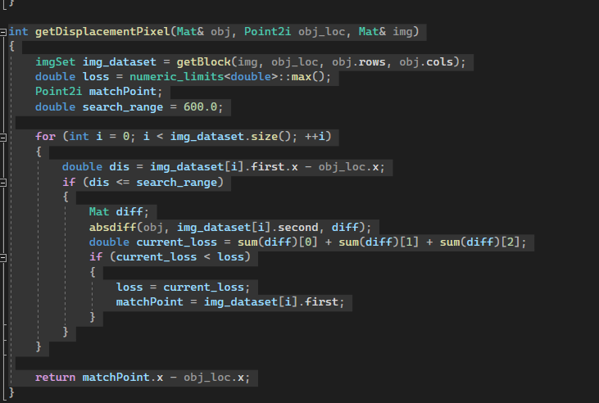

Theoretical Formula

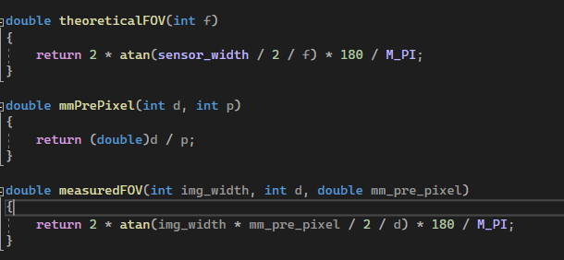

The output table:

|  |  |  |  |  |  |  |
| --- | --- | --- | --- | --- | --- | --- |
| Focal length(mm) | Object distance(mm) | Object actual displacement(mm) | Object displacement(pixel) | mm/pixel | FOV theoretical value(degree) | FOV measured value(degree) |
| 18 | 600 | 1 | 7 | 0.142857 | 66.0477 | 58.1648 |
| 18 | 600 | 5 | 28 | 0.178571 | 66.0477 | 69.617 |
| 18 | 600 | 10 | 56 | 0.178571 | 66.0477 | 69.617 |
| 18 | 600 | 20 | 106 | 0.188679 | 66.0477 | 72.6014 |
| 18 | 1200 | 1 | 2 | 0.5 | 66.0477 | 88.4516 |
| 18 | 1200 | 5 | 16 | 0.3125 | 66.0477 | 62.6271 |
| 18 | 1200 | 10 | 30 | 0.333333 | 66.0477 | 65.9582 |
| 18 | 1200 | 20 | 56 | 0.357143 | 66.0477 | 69.617 |
| 18 | 1800 | 1 | 3 | 0.333333 | 66.0477 | 46.7859 |
| 18 | 1800 | 5 | 9 | 0.555556 | 66.0477 | 71.5823 |
| 18 | 1800 | 10 | 19 | 0.526316 | 66.0477 | 68.6694 |
| 18 | 1800 | 20 | 45 | 0.444444 | 66.0477 | 59.9518 |
| 53 | 600 | 1 | 22 | 0.045455 | 24.8973 | 20.0714 |
| 53 | 600 | 5 | 64 | 0.078125 | 24.8973 | 33.836 |
| 53 | 600 | 10 | 134 | 0.074627 | 24.8973 | 32.4022 |
| 53 | 600 | 20 | 275 | 0.072727 | 24.8973 | 31.6191 |
| 53 | 1200 | 1 | 9 | 0.111111 | 24.8973 | 24.4097 |
| 53 | 1200 | 5 | 44 | 0.113636 | 24.8973 | 24.9473 |
| 53 | 1200 | 10 | 78 | 0.128205 | 24.8973 | 28.0264 |
| 53 | 1200 | 20 | 162 | 0.123457 | 24.8973 | 27.0271 |
| 53 | 1800 | 1 | 12 | 0.083333 | 24.8973 | 12.3449 |
| 53 | 1800 | 5 | 37 | 0.135135 | 24.8973 | 19.8942 |
| 53 | 1800 | 10 | 59 | 0.169492 | 24.8973 | 24.8107 |
| 53 | 1800 | 20 | 102 | 0.196078 | 24.8973 | 28.5537 |
| 135 | 600 | 1 | 61 | 0.016393 | 9.90651 | 7.30391 |
| 135 | 600 | 5 | 164 | 0.030488 | 9.90651 | 13.5386 |
| 135 | 600 | 10 | 268 | 0.037313 | 9.90651 | 16.5315 |
| 135 | 600 | 20 | 510 | 0.039216 | 9.90651 | 17.3617 |
| 135 | 1200 | 1 | 37 | 0.027027 | 9.90651 | 6.02341 |
| 135 | 1200 | 5 | 62 | 0.080645 | 9.90651 | 17.844 |
| 135 | 1200 | 10 | 151 | 0.066225 | 9.90651 | 14.6919 |
| 135 | 1200 | 20 | 317 | 0.063092 | 9.90651 | 14.0038 |
| 135 | 1800 | 1 | 3 | 0.333333 | 9.90651 | 46.7859 |
| 135 | 1800 | 5 | 32 | 0.15625 | 9.90651 | 22.9258 |
| 135 | 1800 | 10 | 88 | 0.113636 | 9.90651 | 16.7784 |
| 135 | 1800 | 20 | 212 | 0.09434 | 9.90651 | 13.9602 |